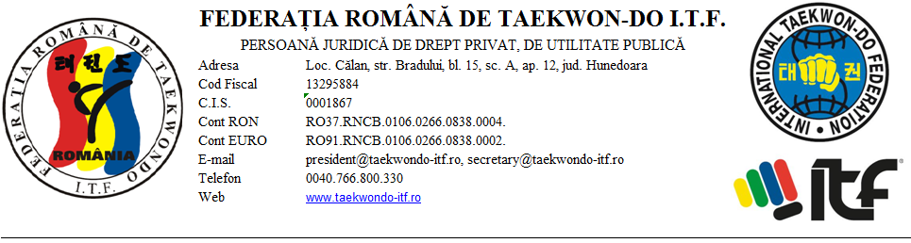
2ND INTERNATIONAL TAEKWON-DO ITF
“GEN. CHOI MEMORIAL” CUP
for JUNIORS I, II, III & SENIORS,
30 June - 02 July 2017, Oradea, Romania
ORGANIZER: TAE-KYON SPORTS CLUB ORADEA
CITY: ORADEA, ROMANIA
PARTICIPANT SPORTING CLUB: ______________________________________________________
INSTRUCTOR: ____________________________________________________________

We are hereby attesting that Sports Club Tae-Kyon and The Romanian TKD Federation are not liable in any way, ethically or materially, for any injury that would occur to the participants during the 2nd International Taekwon-do ITF „Gen. Choi Memorial” Cup event held in Oradea, Romania between the 30th of June and 2nd of July 2017
# | Competitor name and surname | Degree / Grade  (gup / dan) | Competitor signature  (for minor children parent’s signature is required)

Head of delegation: Name / Surname / Degree : ______________________________

Signature and stamp .....................................................

